REPORT
ON
Unit 4 :Graph

Submitted by: Gaykwad Jidnyasa santosh
Roll No.: 176 Class/Division:SY. B.tech. A
Department:Electronics and telecommunication
Subject : Data structure and Algorithm

1. Problem Statement
Develop a C++ program to represent campus buildings and pathways as an undirected graph using an adjacency list. Apply Breadth-First Search (BFS) and Depth-First Search (DFS) from a user-selected starting building to examine campus connectivity. Display the BFS and DFS traversal orders, count the number of buildings reachable from the selected building, and identify isolated buildings that have no connecting pathways.

2. Objectives
- Represent campus buildings as vertices and pathways as edges in a graph.
- Use an adjacency list to store connections between buildings.
- Implement BFS and DFS traversal from a selected starting building.
- Display the traversal order produced by both algorithms.
- Count the buildings reachable from the selected starting building.
- Identify isolated buildings that have no connecting pathways.
- Understand how graph algorithms can be used to analyze campus connectivity.

3. Theory
A graph is a non-linear data structure consisting of vertices and edges. In this project, each campus building is a vertex and each pathway is an edge. The graph is undirected because a pathway is treated as connecting the two buildings in both directions.
An adjacency list stores, for each building, a list of directly connected buildings. It is memory-efficient for sparse graphs and makes it convenient to examine a building's neighbors.
Breadth-First Search (BFS) visits vertices level by level using a queue. Depth-First Search (DFS) explores one branch as far as possible before backtracking, commonly using recursion or a stack. Both algorithms can identify all vertices reachable from a start vertex.
An isolated building is a vertex with degree zero, meaning its adjacency list contains no neighboring buildings. A building may have connections but still be unreachable from the chosen start if it belongs to a separate connected component.

4. Algorithms

4.1 Creating the Campus Graph
- Start.
- Read the number of buildings and their names.
- Initialize an empty adjacency list for every building.
- Read the number of pathways.
- For each pathway, read the two building indices u and v and add v to u's list and u to v's list.
- Read and validate the starting building index.
- Continue with BFS, DFS, reachability counting, and isolated-building detection.

4.2 BFS Algorithm
- Mark all buildings as unvisited and create an empty queue.
- Mark the starting building visited and enqueue it.
- While the queue is not empty, dequeue the front building and display its name.
- For each adjacent building, if it is unvisited, mark it visited and enqueue it.
- Stop when the queue becomes empty.

4.3 DFS Algorithm
- Initialize all buildings as unvisited.
- Mark the current building as visited and display its name.
- For each adjacent building, recursively visit it if it has not been visited.
- Stop when no unvisited adjacent buildings remain.

4.4 Counting Reachable Buildings
- Initialize a counter to zero.
- Perform BFS from the selected starting building.
- Increment the counter whenever a building is removed from the queue and processed.
- Display the final count after the queue becomes empty.

4.5 Identifying Isolated Buildings
- Examine the adjacency list of every building.
- If a building's adjacency list is empty, report it as isolated.
- If no such building exists, display 'None'.

5. C++ Source Code
#include <iostream>
#include <vector>
#include <queue>
#include <string>
using namespace std;
class CampusGraph {
int n;
vector<string> buildings;
vector<vector<int>> adj;
public:
CampusGraph(int size) : n(size), buildings(size), adj(size) {}
void setBuildings() {
cout << "Enter building names (use one word per name):\n";
for (int i = 0; i < n; i++) {
cout << "Building " << i << ": ";
cin >> buildings[i];
}
}
void addPath(int u, int v) {
adj[u].push_back(v);
adj[v].push_back(u);
}
void BFS(int start) {
vector<bool> visited(n, false);
queue<int> q;
visited[start] = true;
q.push(start);
cout << "\nBFS Traversal: ";
while (!q.empty()) {
int u = q.front();
q.pop();
cout << buildings[u] << " ";
for (int v : adj[u]) {
if (!visited[v]) {
visited[v] = true;
q.push(v);
}
}
}
cout << '\n';
}
void DFSUtil(int u, vector<bool>& visited) {
visited[u] = true;
cout << buildings[u] << " ";
for (int v : adj[u]) {
if (!visited[v])
DFSUtil(v, visited);
}
}
void DFS(int start) {
vector<bool> visited(n, false);
cout << "DFS Traversal: ";
DFSUtil(start, visited);
cout << '\n';
}
int countReached(int start) {
vector<bool> visited(n, false);
queue<int> q;
int count = 0;
visited[start] = true;
q.push(start);
while (!q.empty()) {
int u = q.front();
q.pop();
count++;
for (int v : adj[u]) {
if (!visited[v]) {
visited[v] = true;
q.push(v);
}
}
}
return count;
}
void findIsolated() {
cout << "Isolated buildings: ";
bool found = false;
for (int i = 0; i < n; i++) {
if (adj[i].empty()) {
cout << buildings[i] << " ";
found = true;
}
}
if (!found) cout << "None";
cout << '\n';
}
};
int main() {
int n, m;
cout << "Enter number of buildings: ";
cin >> n;
if (n <= 0) {
cout << "Invalid number of buildings.\n";
return 0;
}
CampusGraph campus(n);
campus.setBuildings();
cout << "Enter number of pathways: ";
cin >> m;
if (m < 0) {
cout << "Invalid number of pathways.\n";
return 0;
}
cout << "Enter pathway connections (building indices):\n";
for (int i = 0; i < m; i++) {
int u, v;
cin >> u >> v;
if (u < 0 || u >= n || v < 0 || v >= n) {
cout << "Invalid building index.\n";
return 0;
}
campus.addPath(u, v);
}
int start;
cout << "Enter starting building index: ";
cin >> start;
if (start < 0 || start >= n) {
cout << "Invalid starting building index.\n";
return 0;
}
campus.BFS(start);
campus.DFS(start);
cout << "Buildings reachable from the starting building: "
<< campus.countReached(start) << '\n';
campus.findIsolated();
return 0;
}

6. Sample Input
5
Library
Canteen
Hostel
Lab
Auditorium
3
0 1
1 2
2 3
0

7. Output

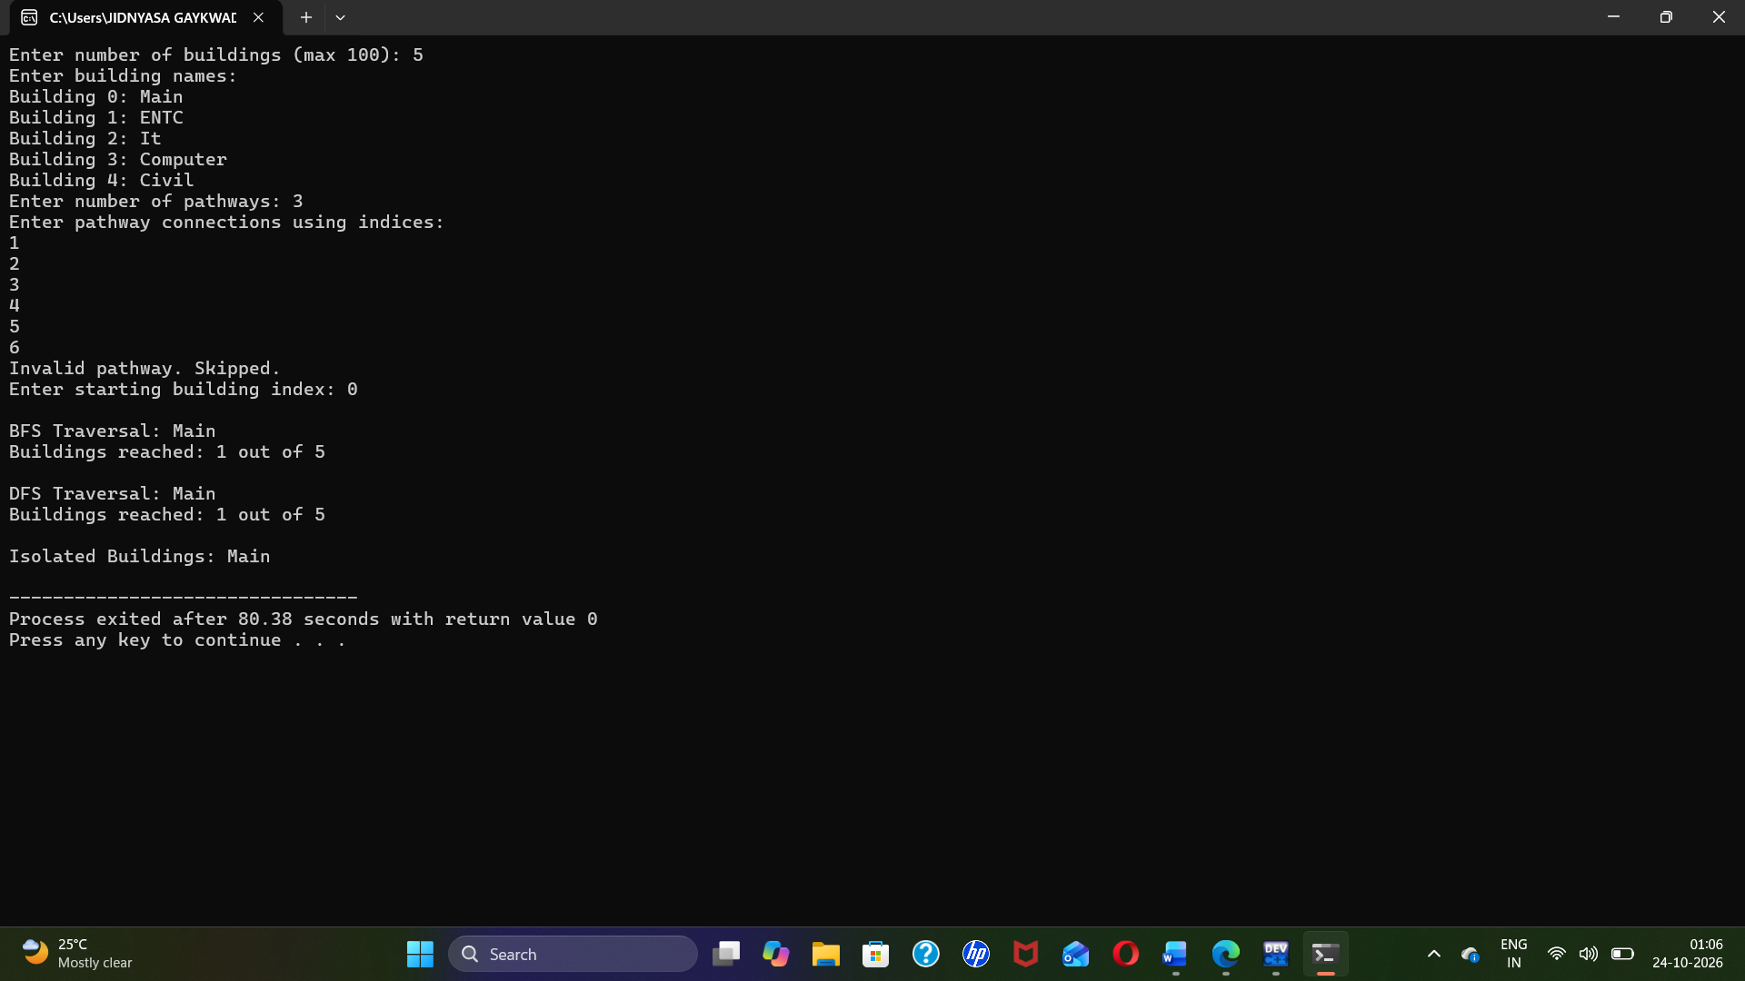

8. Explanation of Output
Starting from Library (index 0), BFS visits the directly connected Canteen, then Hostel, and then Lab. DFS produces the same order for this particular graph because the connections form a simple chain and the adjacency lists are inserted in that order. Four buildings are reachable from Library. Auditorium has no pathway, so it is identified as isolated.

9. Flowchart
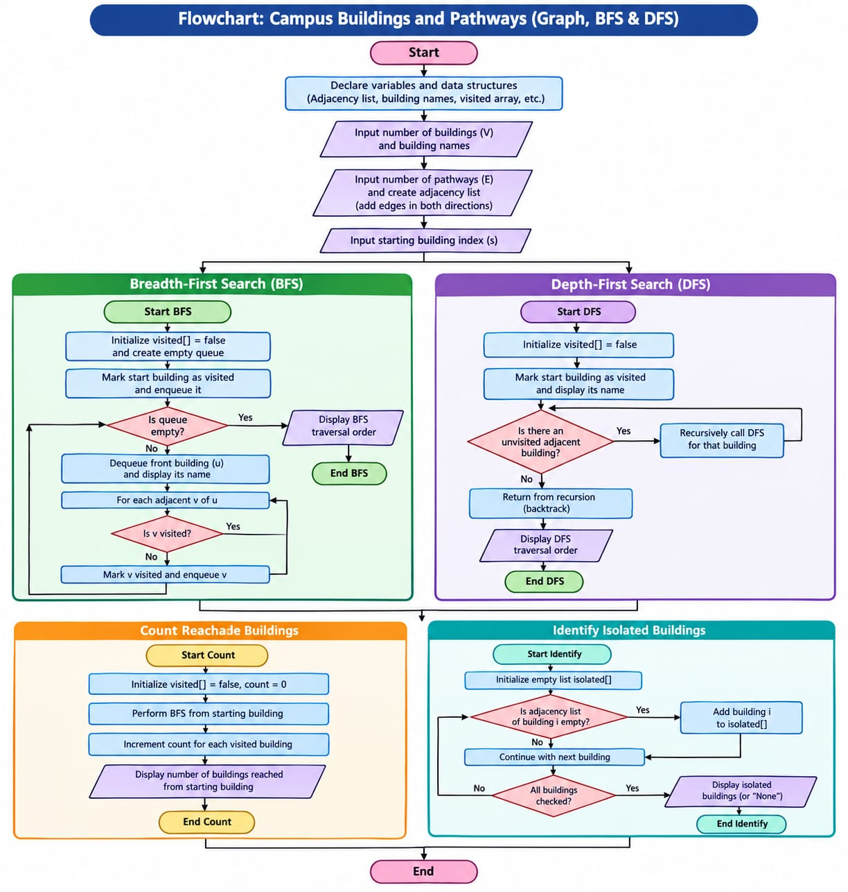.
For a handwritten or drawn flowchart, use ovals for Start/End, parallelograms for input/output, rectangles for processing, diamonds for decisions, and arrows to show control flow.

10. Time and Space Complexity
Let V be the number of buildings and E be the number of pathways. With an adjacency list, BFS takes O(V + E) time and DFS takes O(V + E) time in the worst case. Counting reachable buildings using BFS also takes O(V + E) time. Identifying isolated buildings takes O(V) time. The graph representation requires O(V + E) space.

11. Applications
- Checking which campus buildings can be reached from a selected building.
- Planning campus walking routes and connectivity.
- Detecting buildings that have no recorded pathway connections.
- Understanding network connectivity in maps, computer networks, and transportation systems.

12. Conclusion
The C++ program represents campus buildings and pathways using an undirected graph and an adjacency list. BFS and DFS are used to traverse the graph from a selected building and display the traversal orders. The program also counts reachable buildings and identifies isolated buildings with no connecting pathways. This demonstrates how graph traversal algorithms can be used to analyze campus connectivity efficiently.

